***Senior Advocate Khimlal Devkota***Constituent Assembly Member/Constitutional Lawyer/ Consultant/Trainer  
PAN: 101575573 | Contact: [977-9851142336] | Email: [khimlaldevkota@tuicms.edu.np]

Balaju, Kathmandu

Request for the Publisher Ownership and ISBN Number

Dear Sir/Madam,

I hope this letter finds you well. I am writing to formally request publisher ownership registration and the allocation of an ISBN for my book "TRANSITIONAL JUSTICE," which focuses on Transitional Justice in Nepal and the world. As the author of this work, I seek to ensure its proper documentation and accessibility within the academic and research community.

In this regard, I kindly request guidance and assistance in obtaining the ISBN through Tribhuvan University Library. I am willing to provide any required documentation to facilitate this process. Your cooperation in this matter will be greatly appreciated.

Please let me know the next steps and any formalities that need to be completed from my end. I look forward to your positive response.

Thank you for your time and support.

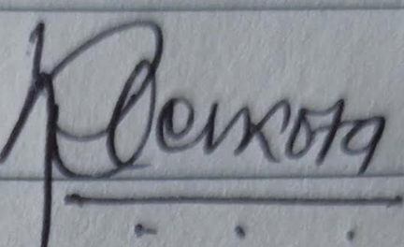

**Authorized Signature:**_________________  
CA Member & Senior Advocate Khimlal Devkota