Date: Nov 25, 2025
The ISBN Unit
Tribhuvan University Central Library
Kirtipur, Kathmandu

Subject: Publication Ownership in the Name of Badri Prasad Badhu

Respected Sir/Madam,
I would like to request the issuance of publication ownership in the name of Badri Prasad Badhu for the purpose of obtaining ISBN for forthcoming publication. I am in the process of publishing a book at present named: “अन्तर्मनका तरङ्गहरू”. This is a collection of poems authored by myself.
I kindly request you to register Badri Prasad Badhu as the official publication/publisher name and grant the necessary approval.
Thank you for your time and consideration.
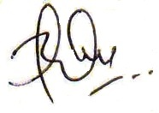

Yours sincerely,
Badri Prasad Badhu
Address
Tinthana, Chandragiri-15
Tel: 9852045159

